HUMAN RIGHTS POLICY STATEMENT

The purpose of this policy is to communicate to the ethical and social values we respect and seek to uphold throughout our business decisions, activities, and partnerships.

We believe that business can only flourish in societies where human rights are protected and respected. We recognise that business has the responsibility to respect human rights and the ability to contribute to positive human rights impacts.

This is an area of growing importance to our stakeholders (as shown below) – our employees and their representatives, agency workers, customers and consumers, suppliers, contractors, the communities where we operate, professional associations and public authorities.
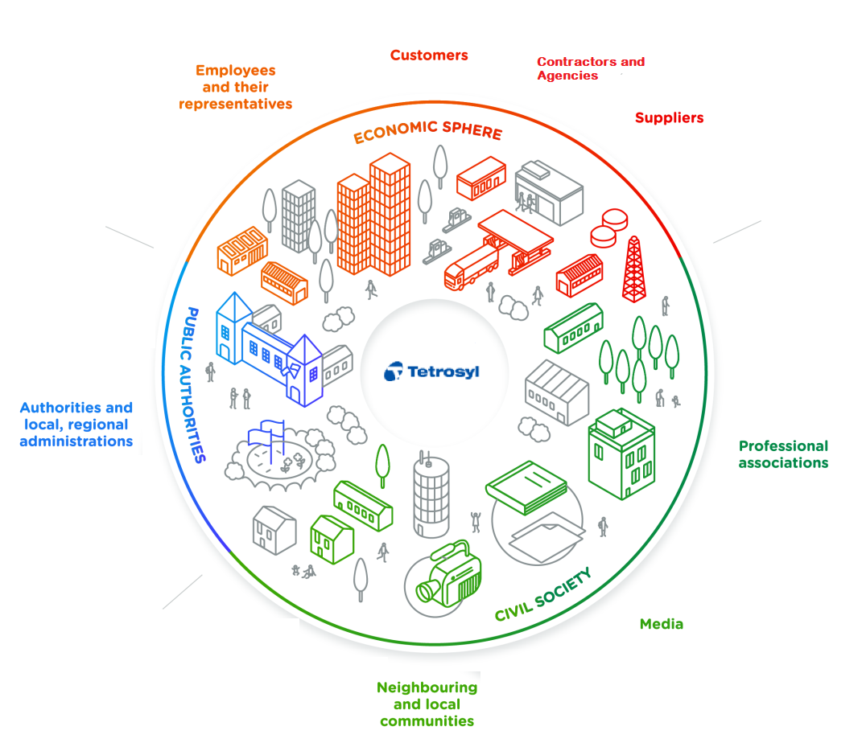

What are human rights?

Human rights are the basic rights and freedoms that belong to every person in the world. They are based on shared values like dignity, fairness, equality, respect, and independence.

Our approach to human rights is based on:

- The United Nations Guiding Principles on Business and Human Rights
- The United Nations Universal Declaration of Human Rights
- The International Labour Organization’s 1998 Declaration on Fundamental Principles and Rights at Work

We are committed to respecting all internationally recognised human rights as relevant to our operations. Our principle is that where national law and international human rights standards differ, we will follow the higher standard; where they are in conflict, we will adhere to national law, while seeking ways to respect international human rights to the greatest extent possible.

In our business dealings we expect our partners to adhere to business principles consistent with our own.

Responsible Sourcing

Our Responsible Sourcing Policy sets out our expectations with regards to the respect for the human rights, including labour rights, of the workers in our supply chain.

We will only work with suppliers who implement our Responsible Sourcing Policy. They must agree to ensure transparency, to remedy any shortcomings, and to drive continuous improvement.

Reporting Human Rights Abuse

If a suspected incident of human rights violation has occurred, this must be reported immediately by confidentially contacting the HR department on the HR admin contact details.

Tel: 07933 182 431

Email: hradmin@tetrosyl.com

Addressing Human Rights Impacts

We recognise that we must take steps to identify and address any actual or potential adverse impacts with which we may be involved whether directly or indirectly through our own activities or our business relationships.

We manage these risks by integrating the responses to our due diligence into our policies and internal systems, acting on the findings, tracking our actions, and communicating with our stakeholders about how we address impacts.

We understand that human rights due diligence is an ongoing process that requires particular attention at certain stages in our business activities, such as when we form new partnerships or our operating conditions change, as these changes may create new potential or actual impacts on human rights.

We recognise the importance of dialogue with our employees, workers and external stakeholders who are or could potentially be affected by our actions. We pay particular attention to individuals or groups who may be at greater risk of negative human rights impacts due to their vulnerability or marginalisation and recognise that women and men may face different risks.

Remedy

We place importance on the provision of effective remedy wherever human rights impacts occur through company-based grievance mechanisms. We continue to build the awareness and knowledge of our employees and workers on human rights, including labour rights, encouraging them to speak up, without retribution, about any concerns they may have, including through our grievance channels.

Responding to Reports of Human Rights Abuse

Typical mechanisms for reporting grievances or abuse are:-

All employees – Grievance procedures, whistleblowing policies, confidential phone line and email, third party reporting such as supplier hotlines, stronger together.

Agency workers – Agency procedures, whistleblowing policies, confidential phone line and email, third party reporting such as supplier hotlines, stronger together.

Customers – customer support email and customer support contact phone lines

Local Community – local council phone lines, community support officers, environment agency, HSE

When specific abuses have been reported or uncovered, they need to be addressed swiftly.

Once it has been identified that human rights are at risk of being violated, action must be taken to remedy them. Urgent steps must be taken to stop the abuse.

The main company functions likely to be involved in the process are:
- Human resources: intermediary contact for workers

- Buying and procurement: main contact with suppliers.

- Trade union or works council: a trusted channel to receive and handle complaints.

- Marketing and customer service: may serve as intermediary between the company and different external stakeholders.

- Legal and compliance: understand legal considerations related to the handling of allegations such as fraud and whistleblowing.

- Health, Safety and Environmental: understand legislation and responsibilities.

- Senior management: may receive some complaints directly.

When human rights abuses are suspected this must be reported to any relevant stakeholders immediately and an investigation carried out.

  - If a worker is found to be involved act quickly and appropriately by removing the worker from the work area for their safety.

  - Record the names, age and contact details of any workers concerned.

  - Involve Law Enforcement if it is suspected that workers are underage or are being subjected to criminal abuse such as modern slavery or human trafficking, law enforcement agencies should be involved immediately.

  - If a person is believed to be trafficked, underage or in immediate danger you should contact emergency services on 999 straight away.

  - Carry out a full investigation into the alleged abuse.

  - If the issue is with a supplier and they are found to be unresponsive to requests for investigation a threat of termination of the contract may be enough to get a positive response that will help the victims.

  - Ensure all stakeholders are kept informed of the progress of the investigations.

  - Ensure any aggrieved parties have reasonable access to sources of information, advice, and expertise necessary to engage in the process on fair and informed terms.

  - Communicate outcomes to all stakeholders.

  - If abuse is found in the supply chain, terminate the relationship.

  - Ensure any measures needed to prevent re-occurrence are put in place.

  - Ensure the victims of violations receive remedy. Examples of remedy can be - apologies, restitution, rehabilitation, financial or non-financial compensation, and punitive sanctions (whether criminal or administrative, such as fines), as well the prevention of harm through, for example, injunctions or guarantees of non-repetition.

We reserve the right to discontinue the relationship with any supplier who has found to be violating human rights, however this will only happen after all avenues to rectify the situation have been exhausted. We reserve the right to carry out audits of our supply chain.

Signed

Ian Tench

Ian Tench
Group Managing Director for Operations and Commercial

Date 09/08/2023

APPENDIX 1
Relevant Procedures:
ETHICAL CODE OF CONDUCT
As detailed in our Ethical Code of Conduct, we’re committed to the highest standards of business ethics which govern the conduct of our business operations for all employees.
SOCIAL ACCOUNTABILITY POLICY
We believe all our employees deserve to be treated with integrity and respect. Therefore, we promote a work environment of transparency and trust. We compensate our employees competitively and operate in compliance with applicable wage, work hours, overtime and benefits laws and international labour standards.
EQUAL OPPORTUNITIES POLICY & DIGNITY AT WORK POLICY
We support and encourage diversity and inclusion within our business and the organizations with which we do business by maintaining workplaces that are free from discrimination or harassment on the basis of race, sex, colour, national or social origin, ethnicity, religion, age, disability, sexual orientation, gender identification or expression, political opinion or any other status protected by applicable law.
HEALTH AND SAFETY POLICY
Our policy is to provide and maintain a safe, healthy, and productive workplace for all our employees that complies with all applicable laws, regulations, and internal policies.
ANTI SLAVERY AND HUMAN TRAFFICKING POLICY
We’re committed to preventing and prohibiting forced labour of any kind, including all forms of modern-day slavery or human trafficking.
CHILD LABOUR POLICY
We do not engage in or condone the unlawful employment or exploitation of children.
FREEDOM OF ASSOCIATION AND COLLECTIVE BARGAINING
We respect the principles of freedom of association and collective bargaining.
DISCLOSURES IN THE PUBLIC INTEREST POLICY
We are committed to support workers who raise protected disclosures (whistleblowing) in line with The Public Interest Disclosure Act 1998.

GRIEVANCE PROCEDURE

For all employees to report any concerns

ETHICAL AUDIT PROCEDURE
We are committed to ensuring all our sites have a SEDEX members ethical trade audit (SMETA) which is less than 2 years old available on the SEDEX platform.

APPENDIX 2
Useful Contacts
Bury Multi-Agency Safeguarding Hub (MASH) Team 0161 253 5678

Crimestoppers: 0800 555 111

HR Admin team: 07933 182 431

HR Manager: 0791 748 9113

Modern Slavery Helpline: 0800 0121 700

NSPCC: 0808 800 5000 or email: help@nspcc.org.uk

Rochdale Council, Children’s Social Care: 01706 647 474

The Equality Advisory and Support Service (EASS): 0808 800 0082
Citizens Advice: 03444 111 444

Useful Websites
Amnesty International: https://www.amnesty.org/en/
Anti-Slavery International: https://productsofslavery.org/ or https://www.antislavery.org/
Equality and Human Rights Commission: https://www.equalityhumanrights.com/en
Ethical Trading Initiative: https://www.ethicaltrade.org/
Government Whistleblowing Help : https://www.gov.uk/whistleblowing/who-to-tell-what-to-expect
Human Rights Foundation: https://hrf.org/
International Labor Organisation: https://www.ilo.org/global/lang--en/index.htm
Stronger Together: https://www.stronger2gether.org/
United Nations Human Rights: https://www.ohchr.org/en/ohchr_homepage
Unseen UK: http://www.unseenuk.org/

